- 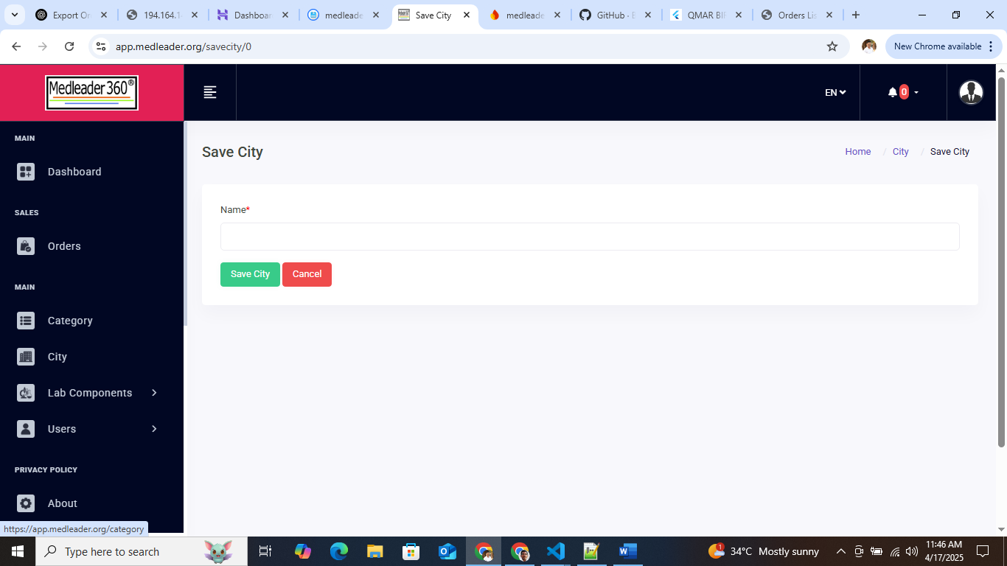
When hit Cancel going to Category page it needs to navigate City page.
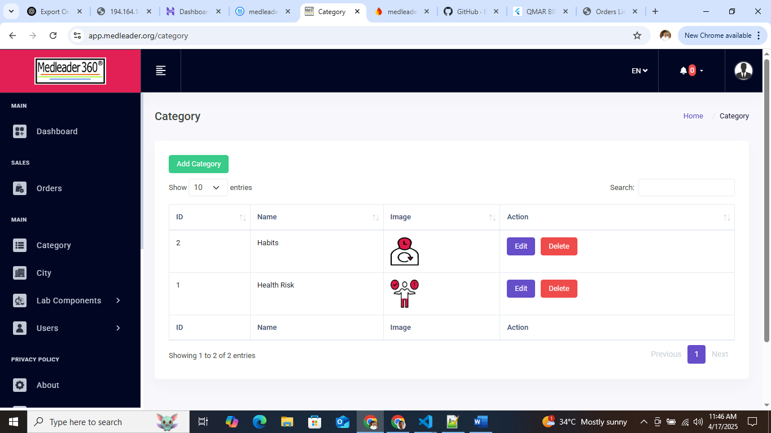

- MRP & Price are not allowing decimal in Parameter Page
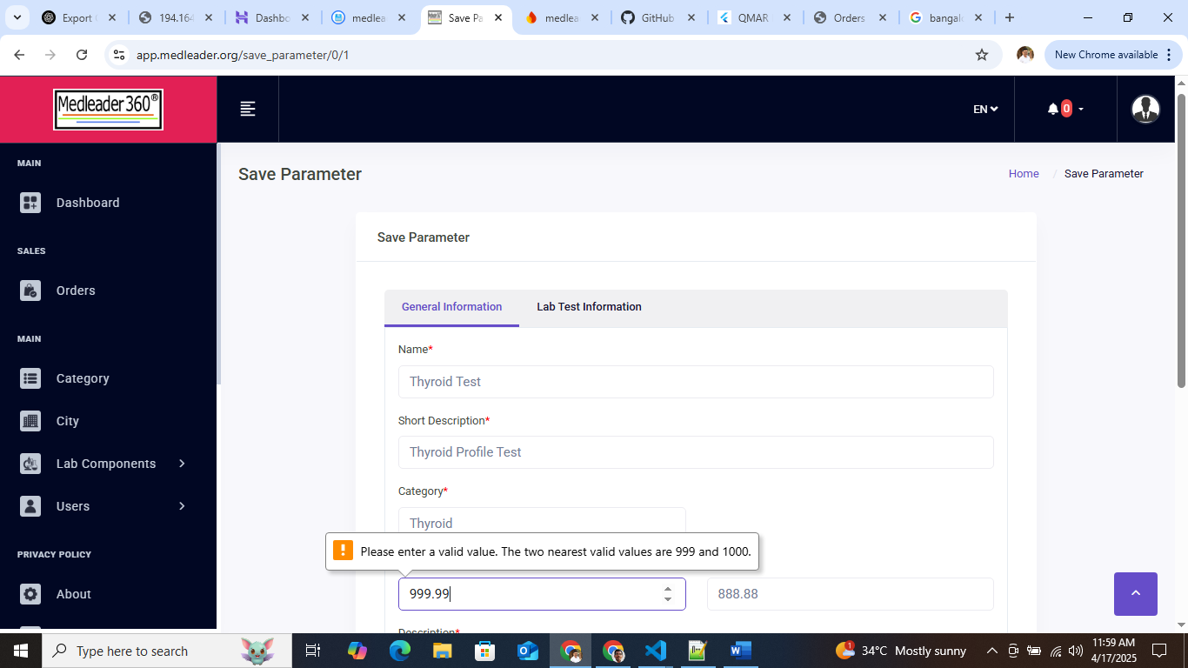
- On Parameter Save button click I don’t know what happening in the screen. Its not showing any progress bar and success message.
Sample Lab Report – is allow all type of file.
I can’t go back to Parameter page. There is now back button.
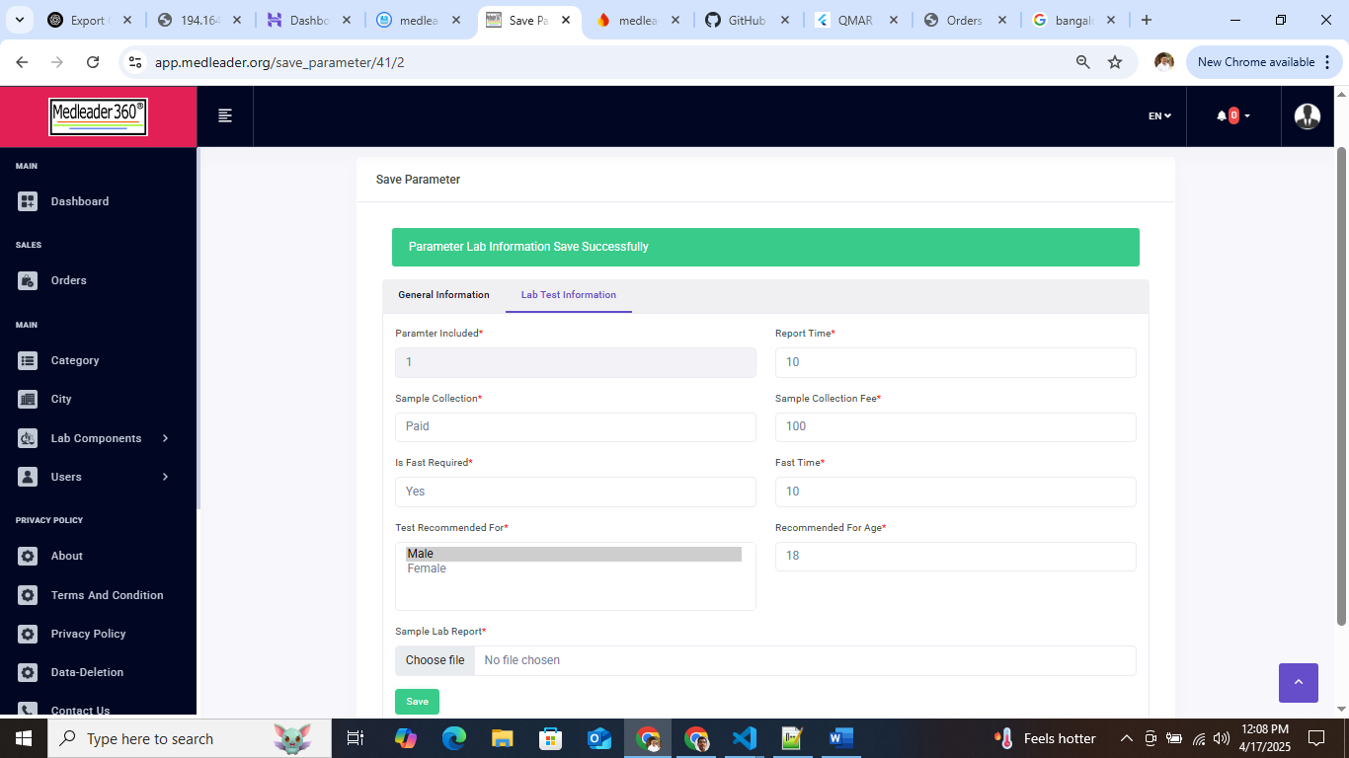

- Compare this detail in both Admin & Customer App.
Where is it coming from? Sample Collection: 2, Test Booked: 1, Fast Time, If test is allow for both sex how can member can choose in Test Recommended field.
It is allowing booking for a member even when the recommended test does not match and the age criteria are not met.
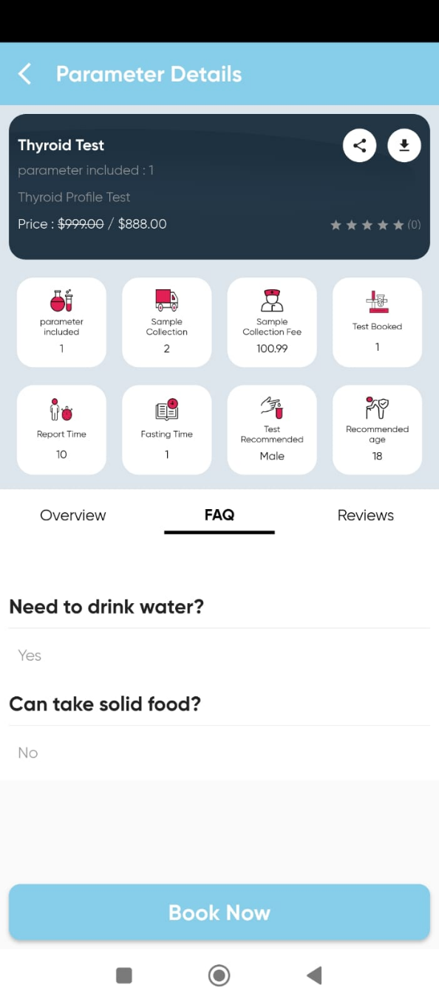
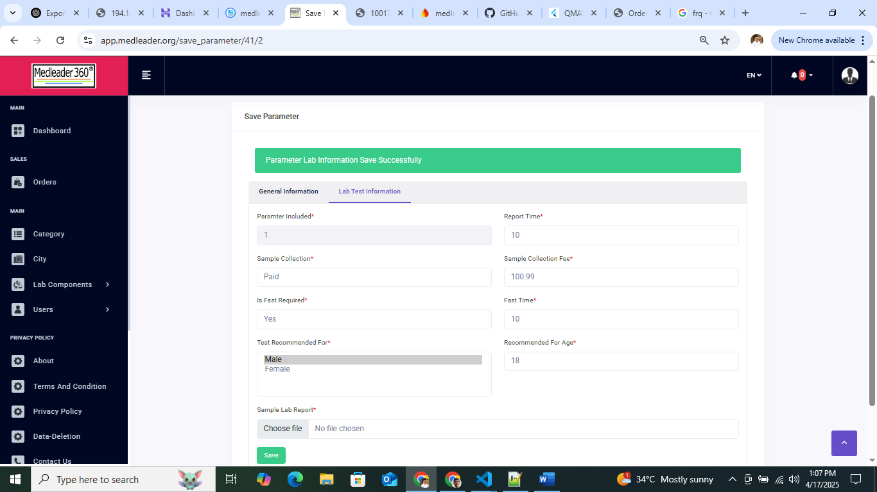

- Cart Item price not included with Sample Collection Fee. This need to change from $ to ₹. How to set tax percentage or amount?
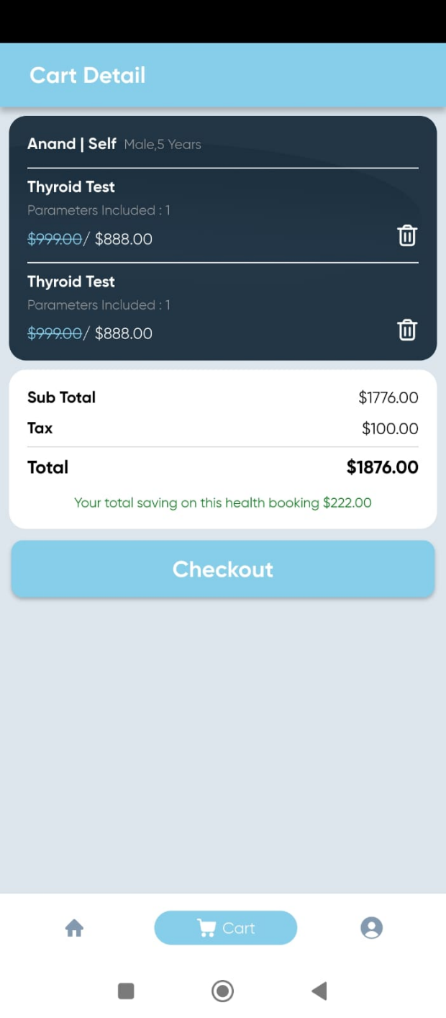
- I can’t zoom in and out on the map using two fingers.
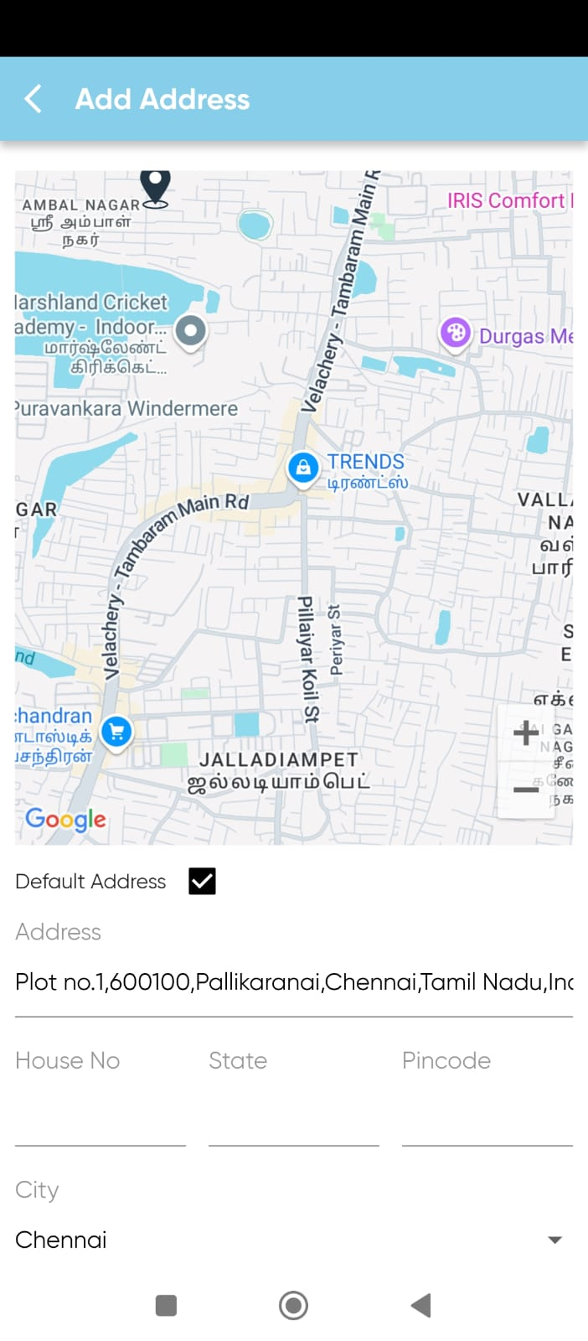

- It is allowing selection of a past Collection Time. Why you didn’t use any payment gateway to pay.
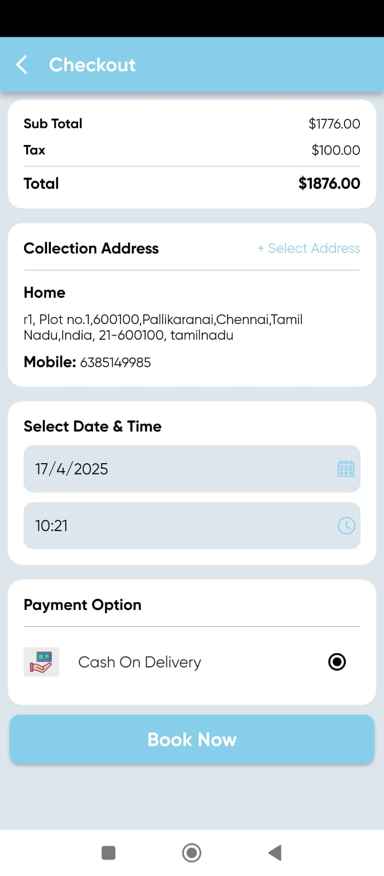
- Why customer name is empty in order list
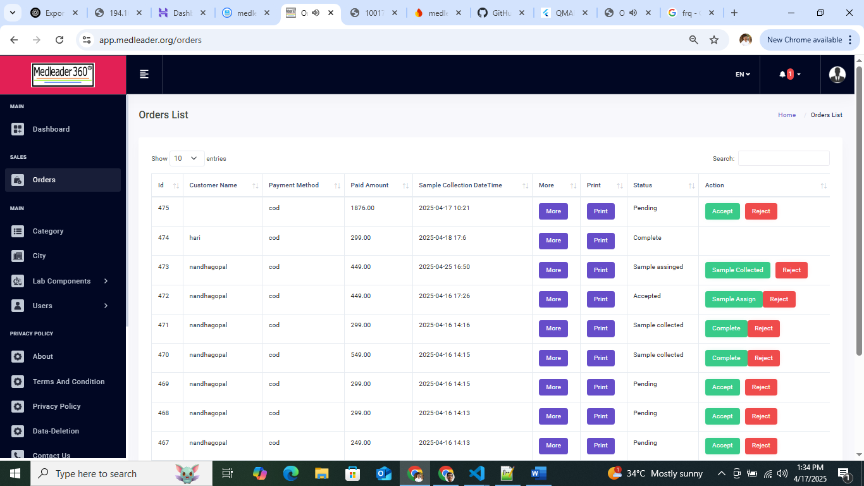

- Show Entity and Search are not working in Sample Collector page.
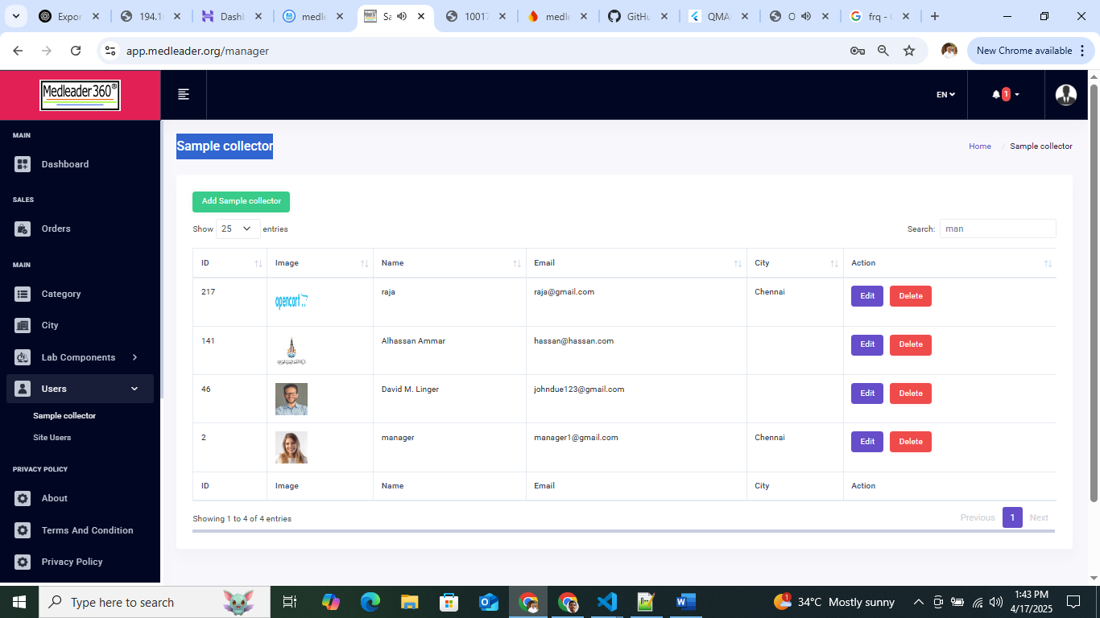
- When processing something why the grid item is hide. Also in lots of places progress bar need to show to avoid what going on the background.
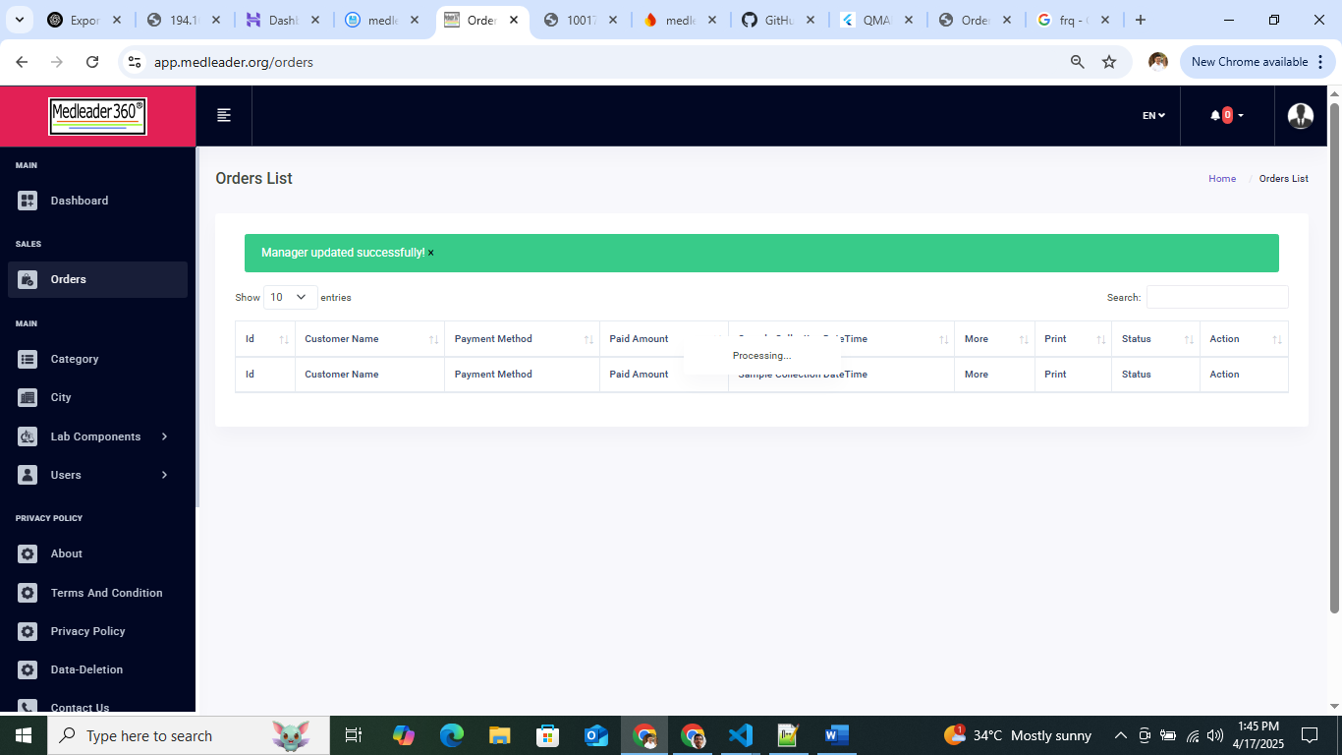

- Before sample collection the status is changed in customer App.
